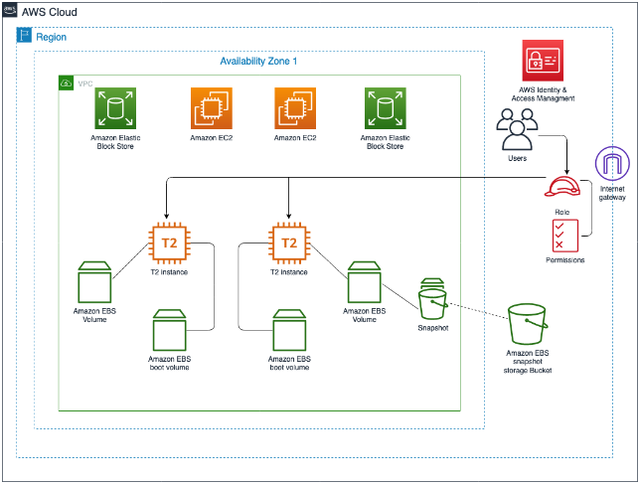

Task 1: Create and attach an EBS volume to an EC2 instance.

* Task 1.1: Name existing EBS volumes.

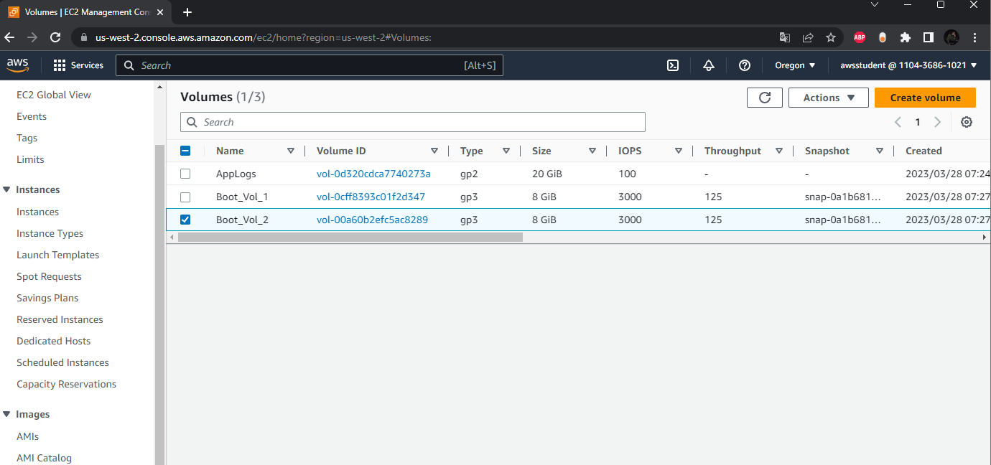

* Renaming the volumes.
* Task 1.2: Create an EBS volume and Task 1.3: Attach EBS volume to an EC2 instance.

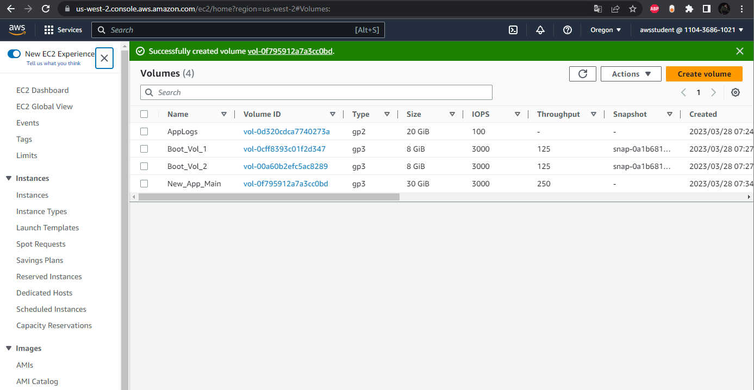

* Creating a new volume.

Task 2: Create and configure a file system on an attached EBS volume.

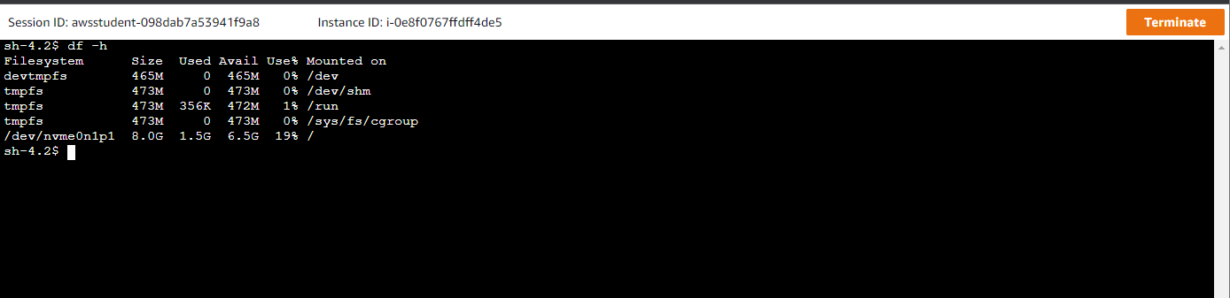

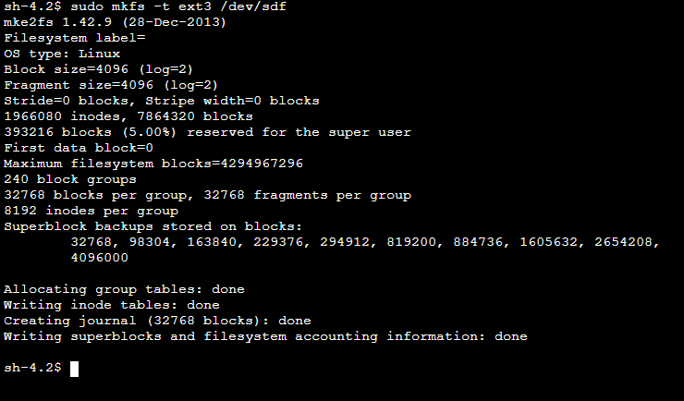

* df –h for checking the free disk space available, and creating a file system.

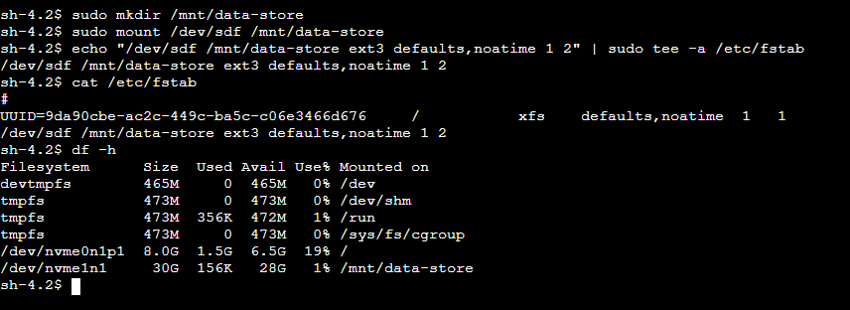

* Creating directory, attaching file system to the storage device.

Task 3: Modify the EBS volume size and expand the file system on the volume.

* 3.1: Modify the size of an existing EBS volume(New_App_Main).

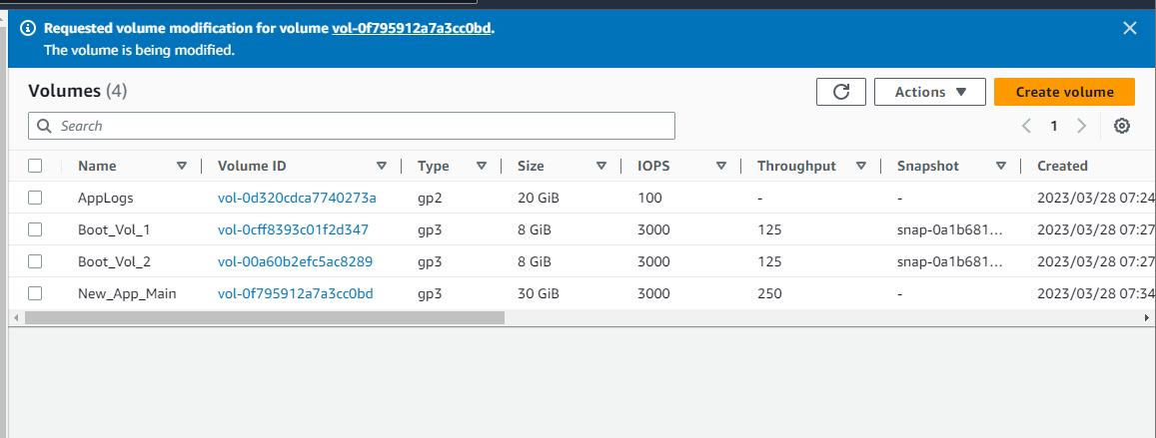

* 3.2: Expand the volume of your file system.

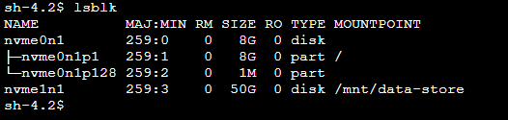

* Listing all available block devices.

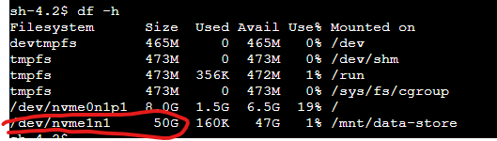

* Resized file system from 30 to 50 GB.

Task 4: Modify the EBS volume type (attached to EC2 instance) and provisioned performance for an existing application.

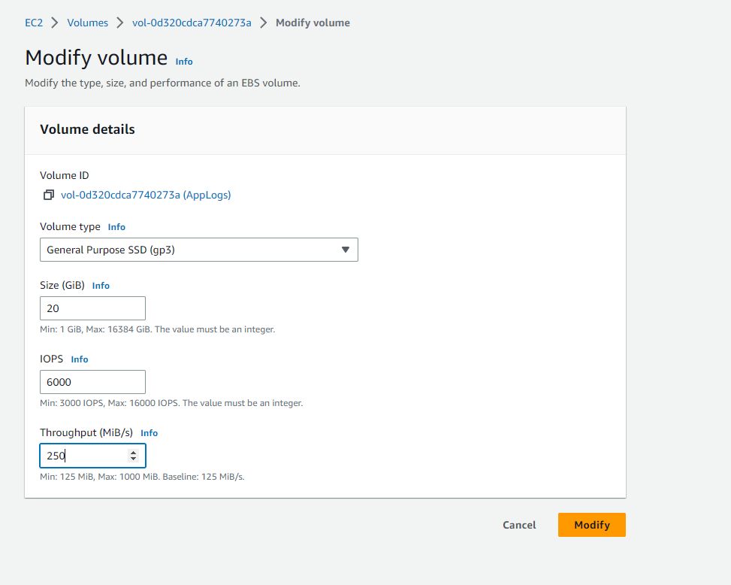

Task 5: Configure a snapshot for an existing EBS volume.

* Created snapshot for App_Main_Snap.

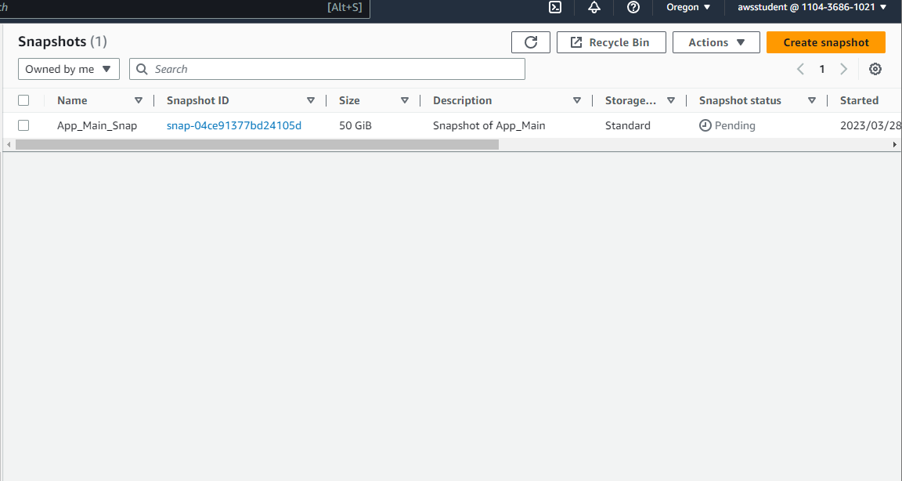

Task 6: Restore an EBS volume from an existing snapshot.

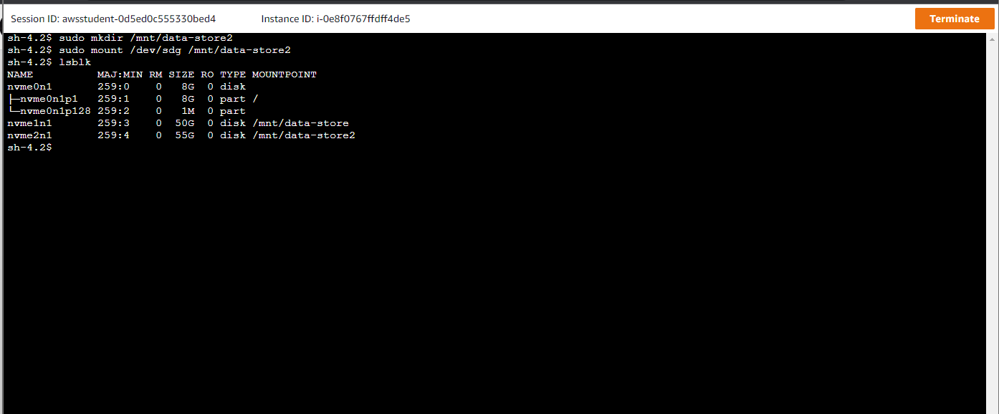

* Session manager on the replica EC2 instance.

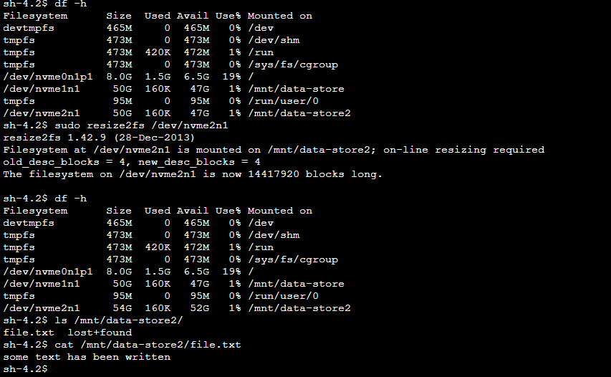

* Resizing the file system(the first and second sizes didn't match):

-/dev/nvm2n1 -> 50G and -/dev/nvm2n1 ->54G.

(Challenge) Task 7:

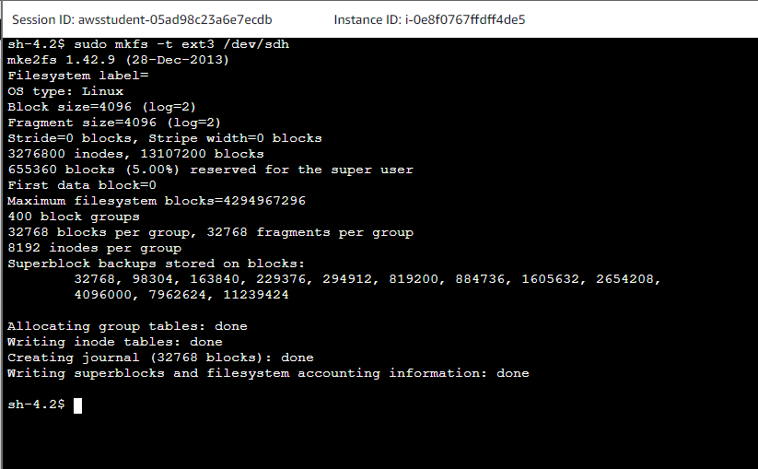

* The output from the challenge task: Creating ext3 Linux file system.

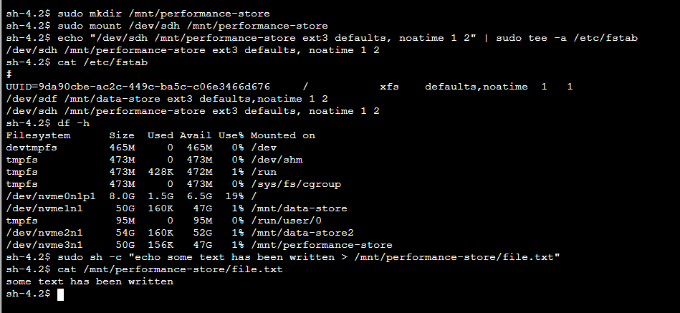

* From the challenge: Creating directory, mount a new storage volume, mount this volume.